NextGen Systems Pte Ltd
Vendor Requirements Specification Template

Document Number: NG-TEMPLATE-VRS-001
Version: 2.0
Effective Date: February 11, 2025
Template Owner: Requirements Analysis Team
Classification: Internal Use

Document Control

Version History
Version | Date | Author | Changes
1.0 | Jan 15, 2025 | Requirements Team | Initial template
2.0 | Feb 11, 2025 | Samuel Mok Wei Sheng | Enhanced based on EduFlow project

Approvals
Name | Role | Date
Samuel Mok Wei Sheng | Lead Analyst | Feb 11, 2025
Bobby Lim | Chief Technology Officer | Feb 11, 2025

1. Executive Summary
This Vendor Requirements Specification Template provides a standardized format for documenting system requirements refined through the BCIC process (Breakdown, Clarify, Interpret, Categorize). Version 2.0 incorporates lessons from the EduFlow project on decomposing compound requirements, clarifying ambiguities, and ensuring specification-ready requirements.
This template is mandatory for all NextGen Systems projects entering the specification phase.

2. Introduction
This template standardizes vendor requirements format, ensures quality through atomic and testable statements, supports traceability, and enables verification.

Scope
Applies to: Business Operations Requirements, Technical Requirements, Functional Requirements, Non-Functional Requirements.
Does NOT apply to: Project management artifacts, design specifications, test plans, user documentation.

3. Template Structure

3.1 Core Requirement Format
REQ-[TYPE]-[LEVEL]-[ID]: [Requirement Title] ([Priority])
Requirement Statement:
[Clear, imperative statement using shall/should/may]
Constraints: (Optional)
- [Specific limitations]
Assumptions: (Optional)
- [Environmental assumptions]
Regulations: (Optional)
- [Applicable laws or standards]
Rationale: (Mandatory for decomposed/clarified)
[Explanation of derivation]
Verification Method: (Recommended)
[Inspection | Demonstration | Analysis | Test]

3.2 Classification System
Format: REQ-[TYPE]-[LEVEL]-[ID]
- TYPE: BIZ, TCR, FUN, SEC, PER
- LEVEL: L0 (System), L1 (Component), L2 (Sub-component)
- ID: Sequential two-digit number

Example: REQ-TCR-L1-04 = Technical Requirement, Component Level, Number 04

3.3 Priority Definitions
Priority | Meaning | Implementation
Essential | Mandatory for system acceptance | Must be implemented
Desirable | Valuable for user satisfaction | Should be implemented if feasible
Acceptable | Nice-to-have; marginal improvement | May be deferred

4. Usage Guidelines

4.1 When to Use
Use AFTER Clarify stage, DURING Interpret stage, when decomposing compound requirements.
Do NOT use during initial Breakdown, for raw customer statements, or for design decisions.

4.2 Writing Principles

Atomic Requirements
Each requirement must express exactly ONE testable obligation.
Bad: "System shall maintain sessions for 8 hours and preserve data during outages"
Good: Split into two separate requirements

Clear Imperative Language
Modal Verb | Priority | Meaning
shall / must | Essential | Mandatory
should | Desirable | Recommended
may | Acceptable | Optional

Testable
Bad: "System shall be user-friendly"
Good: "System shall complete workflows in fewer than 5 user actions"

4.3 Common Pitfalls
Pitfall | Fix
Describing process, not system | Ask: Is this what the system does, or how we build it?
Mixing multiple obligations | Look for "and" - split into separate requirements
Vague quantifiers | Replace with specific numbers or thresholds
Unverifiable qualities | Define objective criteria

5. Classification Guidelines

5.1 Requirement Type Codes
Code | Type | Description
BIZ | Business Operations | Organizational responsibilities, workflows
TCR | Technical | Platform, infrastructure, development
FUN | Functional | System behaviors, features, interactions
SEC | Security | Authentication, authorization, data protection
PER | Performance | Response time, throughput, capacity

5.2 Requirement Levels
Level | Scope | Description
L0 | System-level | Architectural, platform, cross-cutting concerns
L1 | Component-level | Specific features, modules, subsystems
L2 | Sub-component | Detailed specifications within a component
Most requirements should be L0 or L1. Use L2 sparingly.

5.3 Priority Classifications

Essential
Requirements without which the system cannot be accepted.
Test: Would the customer reject the system if this is missing?

Desirable
Significantly improves utility but not mandatory.
Test: Would users be significantly disappointed without this?

Acceptable
Marginal improvement or edge cases.
Test: Would most users notice if this is missing?

6. Template Format Reference
Requirement Statement: ONE sentence with clear imperative verb (shall/should/may)
Constraints: Limitations imposed BY the requirement
Assumptions: Conditions that must be true FOR the requirement to work
Regulations: Applicable laws, standards, or policies
Rationale: Mandatory when decomposed or reframed; explain derivation
Verification Method: Inspection, Demonstration, Analysis, or Test

7. Requirements Catalogue

7.1 Business Operations Requirements – L0
REQ-BIZ-L0-01: Cross-Platform Support (Essential)
Requirement Statement: The system must be delivered as a native mobile application compatible with both Android (Version 12+) and iOS (Version 15+).
Constraints:
- The application must maintain a consistent feature set across both operating systems.
Assumptions:
- Target devices have active internet connectivity and meet the minimum hardware specifications for the supported OS versions.
Verification Method: Functional parity testing across both Android 12+ and iOS 15+ devices

REQ-BIZ-L0-02: Functional Scope (Essential)
Requirement Statement: The system shall provide dedicated modules for academic scheduling and attendance tracking.
Constraints:
- Usage of these modules must be restricted to users authenticated via provided email and password.
Assumptions:
- Accurate academic timetables and student enrollment lists are available via the institution's backend database API.
- The institution has a predefined registry of "Authorized Users" (Staff/Student) to map permissions correctly.
Regulations:
- Personal Data Protection Act (PDPA)
Verification Method: Demonstration of scheduling and attendance modules with authenticated user accounts

REQ-BIZ-L0-03: Attendance Capture (Essential)
Requirement Statement: The mobile application must enable students to record attendance by scanning a system-generated QR code which will be provided by the teachers.
Constraints:
- Attendance recording shall only be active during the window of a scheduled session as defined by the Institutional Timetable.
Assumptions:
- Teaching venues are equipped with functional display hardware (projectors/screens) to show the capture method.
- The mobile device's camera is functional and permitted to access the application for scanning.
Verification Method: Test: scan QR code within and outside session window; verify correct acceptance and rejection

7.2 Business Operations Requirements – L1
REQ-BIZ-L1-01: Entry Representation (Essential)
Requirement Statement: The system shall present a visible application entry point on the mobile device that allows users to launch the application.
Verification Method: Inspection: confirm app icon appears on home screen after installation

REQ-BIZ-L1-02: User Authentication (Essential)
Requirement Statement: The system shall present an authentication interface to users prior to granting access to system functions.
Verification Method: Demonstration: verify login screen appears on app launch before any function is accessible

REQ-BIZ-L1-03: Scheduling and Timetable Presentation (Essential)
Requirement Statement: The system shall present scheduling and timetable information relevant to the authenticated user.
Verification Method: Demonstration: log in as different user roles and verify only relevant schedule is shown

REQ-BIZ-L1-04: Attendance Interaction Interface (Essential)
Requirement Statement: The system shall present an interface that allows authorised users to initiate and conduct attendance interactions during scheduled sessions.
Verification Method: Demonstration: initiate attendance interaction as authorized staff during scheduled session

REQ-BIZ-L1-05: Attendance Record Display (Essential)
Requirement Statement: The system shall display attendance records relevant to the authenticated user.
Constraints:
- Display is limited to read-only access; modification capabilities are outside the scope of this requirement.
- Records are filtered based on user role and authorization level.
Assumptions:
- Attendance records exist in the backend system and are accessible via API.
Rationale: Decomposed from original REQ-BIZ-L1-05 to clarify view-only scope. Stakeholders confirmed this requirement addresses display only, not record modification.
Verification Method: Demonstration testing with sample data across user roles; verify read-only access

7.3 Technical Requirements – L0
REQ-TCR-L0-01: Mobile Operating System Compatibility (Essential)
Requirement Statement: The system shall be compatible with commercial off-the-shelf Android and iOS operating systems.
Constraints:
- Support is limited to mobile operating systems officially supported by device manufacturers.
Assumptions:
- Users operate devices running supported Android or iOS versions.
Verification Method: Inspection: verify app installs and runs on minimum supported OS versions

REQ-TCR-L0-02: Cross-Platform Application Framework (Essential)
Requirement Statement: The system shall be implemented using a development framework or approach that supports deployment to both Android and iOS platforms.
Constraints:
- Platform-specific implementations shall not prevent functional parity across supported platforms.
Assumptions:
- A single development approach can be adopted to support both platforms.
Verification Method: Inspection of project configuration; functional parity testing on both platforms

REQ-TCR-L0-03: Programming Language and Tooling (Essential)
Requirement Statement: The system must be developed using Swift 5.0+ (iOS) and Kotlin 1.9+ (Android). All development must utilize the current stable versions of Xcode and Android Studio.
Constraints:
- Third-party libraries with "Deprecated" status in official documentation shall not be included in the production build.
Assumptions:
- The institution's IT environment provides network permissions to access official Apple Developer and Google Play Console endpoints and allows installation of IDE-specific SDKs.
Rationale: Reframed from original vague wording. Customer concern was long-term maintainability. Institution standardized on Swift and Kotlin for internal IT support capability.
Verification Method: Code review and build configuration inspection; automated static analysis for deprecated libraries

REQ-TCR-L0-04: Hosting and Server Environment (Essential)
Requirement Statement: The system shall rely on an institution-managed or vendor-managed server environment to support application services and data storage.
Constraints:
- Hosting solutions must be compatible with the institution's existing IT infrastructure.
Assumptions:
- Server and network infrastructure are provisioned outside the project scope.
Verification Method: Inspection of deployment configuration against institutional IT requirements

REQ-TCR-L0-05: Data Security Management (Essential)
Requirement Statement: The system shall implement technical measures to protect personal and attendance-related data during storage and transmission.
Constraints:
- Security controls must be applied consistently across mobile and server components.
Assumptions:
- Users access the system through trusted personal or institutional devices.
Regulations:
- Personal Data Protection Act (PDPA)
Verification Method: Analysis: security audit of data encryption at rest and in transit

REQ-TCR-L0-06: Browser and Device Constraints (Acceptable)
Requirement Statement: The system shall not require browser-based access and shall be optimised for mobile device usage only.
Constraints:
- Desktop or browser-only access is outside the system scope.
Assumptions:
- Mobile devices are the primary access method for users.
Verification Method: Inspection: confirm no browser-based entry points exist in the system

REQ-TCR-L0-07: Technical Documentation (Essential)
Requirement Statement: The system must be delivered with a Technical Maintenance Manual including API specifications, database schemas, and deployment configurations.
Constraints:
- Documentation must be provided in a machine-readable format (e.g., Markdown or PDF).
Assumptions:
- Institutional IT staff possess the necessary technical skills to interpret standard architectural diagrams.
Verification Method: Inspection: verify all required documentation artefacts are delivered at handover

REQ-TCR-L0-08: User Documentation (Desirable)
Requirement Statement: The system shall include a User Guide covering core application workflows and troubleshooting steps.
Constraints:
- The guide must be accessible directly within the application via a "Help" or "FAQ" section.
Assumptions:
- Users possess basic mobile device proficiency (e.g., navigating menus, using touch gestures).
- The primary language of the user base is English.
Verification Method: Demonstration: navigate to Help/FAQ section within the app; verify content covers core workflows

7.4 Technical Requirements – L1
REQ-TCR-L1-01: Authentication and Access Control Mechanism (Essential)
Requirement Statement: The system shall implement technical mechanisms to enforce authenticated and authorised access to application components.
Verification Method: Test: attempt to access protected components without authentication; verify access is denied

REQ-TCR-L1-02: QR-Based Attendance Support (Essential)
Requirement Statement: The system shall support technical generation of attendance taking methods, such as QR codes, for use during scheduled sessions.
Verification Method: Demonstration: generate QR code during a scheduled session and verify it is scannable

REQ-TCR-L1-03: Performance Expectations (Desirable)
Requirement Statement: The system shall be designed to provide response times of less than 3 seconds for common user interactions under normal operating conditions.
Verification Method: Analysis: load testing with simulated users; measure 95th percentile response time

REQ-TCR-L1-04: Session Duration Management (Desirable)
Requirement Statement: The system shall maintain an authenticated user session for a minimum of 8 continuous hours without requiring re-authentication.
Rationale: Decomposed from original compound requirement. Addresses authentication persistence: staff teach multiple classes throughout the day and should not need to re-authenticate between sessions.
Verification Method: Test: authenticate user at T=0; verify session active at 1hr, 4hr, 8hr; verify expired at 9hr

REQ-TCR-L1-05: Offline Data Preservation (Desirable)
Requirement Statement: The system shall preserve unsaved attendance data for up to 15 minutes during temporary network disconnection.
Rationale: Decomposed from original compound requirement. Addresses network resilience: certain campus buildings have poor Wi-Fi. 15-minute window covers 90% of typical outages.
Verification Method: Test: simulate network disconnection during attendance capture; verify data persists for 15 minutes

REQ-TCR-L1-06: Maintainability and Update Support (Acceptable)
Requirement Statement: The system shall support maintenance activities, including updates and defect resolution, without disrupting core application usage.
Verification Method: Demonstration: apply a minor update and verify core functions remain operational

8. Requirements Traceability Matrix
Req ID | Title | Priority | Analysis Stage | Change Reason | Status
REQ-BIZ-L0-01 | Cross-Platform Support | Essential | Categorize | New | Approved
REQ-BIZ-L0-02 | Functional Scope | Essential | Categorize | New | Approved
REQ-BIZ-L0-03 | Attendance Capture | Essential | Categorize | New | Approved
REQ-BIZ-L1-01 | Entry Representation | Essential | Categorize | New | Approved
REQ-BIZ-L1-02 | User Authentication | Essential | Categorize | New | Approved
REQ-BIZ-L1-03 | Scheduling and Timetable Presentation | Essential | Categorize | New | Approved
REQ-BIZ-L1-04 | Attendance Interaction Interface | Essential | Categorize | New | Approved
REQ-BIZ-L1-05 | Attendance Record Display | Essential | Clarify | Scope clarification | Approved
REQ-TCR-L0-01 | OS Compatibility | Essential | Categorize | New | Approved
REQ-TCR-L0-02 | Cross-Platform Framework | Essential | Categorize | New | Approved
REQ-TCR-L0-03 | Programming Language and Tooling | Essential | Interpret | Specificity enhanced | Approved
REQ-TCR-L0-04 | Hosting and Server Environment | Essential | Categorize | New | Approved
REQ-TCR-L0-05 | Data Security Management | Essential | Categorize | New | Approved
REQ-TCR-L0-06 | Browser and Device Constraints | Acceptable | Categorize | New | Approved
REQ-TCR-L0-07 | Technical Documentation | Essential | Categorize | New | Approved
REQ-TCR-L0-08 | User Documentation | Desirable | Categorize | New | Approved
REQ-TCR-L1-01 | Auth and Access Control Mechanism | Essential | Categorize | New | Approved
REQ-TCR-L1-02 | QR-Based Attendance Support | Essential | Categorize | New | Approved
REQ-TCR-L1-03 | Performance Expectations | Desirable | Categorize | New | Approved
REQ-TCR-L1-04 | Session Duration Management | Desirable | Interpret | Decomposed from L1-04 | Approved
REQ-TCR-L1-05 | Offline Data Preservation | Desirable | Interpret | Decomposed from L1-04 | Approved
REQ-TCR-L1-06 | Maintainability and Update Support | Acceptable | Categorize | New | Approved

9. Quality Assurance

9.1 Quality Checklist
Before finalizing any requirement, verify:
- Atomic: Expresses exactly ONE testable obligation
- Clear Imperative: Uses shall/should/may correctly
- Testable: Can write a test case with objective criteria
- Complete: All constraints, assumptions, and context provided
- Consistent: No conflicts with other requirements
- Traceable: Links to original customer requirements
- Unambiguous: No subjective terms (adequate, suitable, user-friendly)

9.2 Peer Review Process
- Self-Review: Author completes quality checklist
- Peer Review: Reviewer applies checklist and provides written feedback
- Revision: Author addresses all feedback
- Approval: Lead Analyst approves for SRS inclusion

10. Appendix

Quick Reference

DO
- Use shall/should/may matching the priority level
- Express a single testable obligation per requirement
- Use specific, measurable criteria
- Document rationale for decomposed or reframed requirements

DO NOT
- Use will/can/might for obligations
- Combine multiple behaviors in one requirement
- Use vague qualifiers (adequate, suitable, user-friendly)
- Describe project processes instead of system characteristics

Verification Methods
Method | Description | Best For
Inspection | Visual examination, code review | Documentation, configuration, UI layout
Demonstration | Show system performs required behavior | User workflows, interactions
Analysis | Mathematical proof, load modeling | Performance, capacity, algorithms
Test | Execute under controlled conditions | Functional behavior, integration

Context Diagram
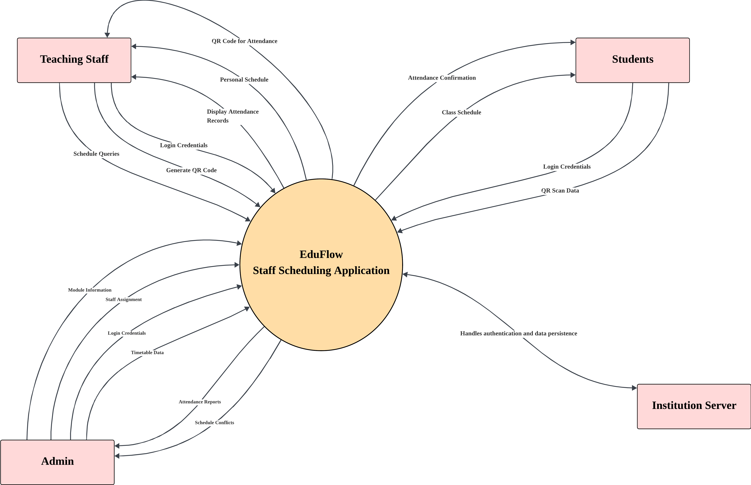

End of Document

NextGen Systems Pte Ltd
72 Digital Hub Avenue, #09-14 | Singapore 018956 | www.nextgensystems.com

